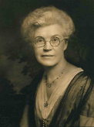
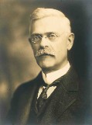
Isaac W. and Carrie M. Carpenter Scholarship Fund
The “Isaac W. and Carrie M. Carpenter Scholarship Foundation” was created by the legacy giving of Melinda C. Lockwood, sister to Isaac Carpenter. Her will established the perpetual scholarship resource for Nebraska Baptists to pursue educational opportunities in college, university, seminary, and similar places of higher learning to prepare for vocational Christian ministry. Additionally, the scholarship provides resources for Nebraska Baptists to pursue lifelong continuing education opportunities that provide Continuing Education Units.
Isaac and Carrie Carpenter and Melinda C. Lockwood were all lifelong members at Calvary Baptist Church in Omaha, Nebraska. Unfortunately, Calvary Baptist closed in 2005. We are grateful for the ongoing legacy of the Carpenter Fund as it continues to aid pastors and leaders in perpetuity.
The Foundation resources are managed by the US Bank in Omaha, Nebraska. Each year ABC Nebraska is given access to a percentage of the earnings of the Foundations investments to distribute for its intended purposes.
Every year, our beloved “Carpenter Fund” continues to help American Baptists in Nebraska attend college and seminary in addition to Nebraska Baptist pastors and church leaders to participate in continuing education, retreats, and conferences.

