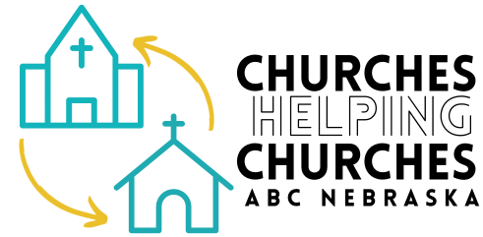
Regional Bookkeeper & Administrative Coordinator
American Baptist Churches of Nebraska
11244 Blondo Street, Omaha NE 68164
(402) 556-4730 www.abcnebraska.com

Rev. Dr. Greg Mamula —Executive Minister, gmamula@abcnebraska.com
Rev. Aaron Sprock—Associate Region Minister, pastor.sprock@gmail.com / Rev. Blake Wilkes—Associate Region Minister, blake52790@gmail.com
Reports To: Executive Minister, ABC Nebraska
Position Type: Part-time, Hourly Rate: $22.00 – $27.00 per hour (depending on experience). We expect a candidate with 2+ years of bookkeeping experience and the ability to manage administrative coordination. The final rate will reflect skills and ministry-fit.
Location: ABC Nebraska Region Office, 11244 Blondo Street, Omaha, NE 68164
The American Baptist Churches of Nebraska (ABC Nebraska) seeks a detail-oriented, mission-minded professional to support our regional ministry through financial management, bookkeeping, and administrative coordination. This position ensures the integrity of ABC Nebraska’s financial systems and contributes to the smooth operation of our office and shared ministries.
Guided by our regional theme “Love with Courage, Lead with Wisdom, and Serve with Compassion,” we seek staff who serve with integrity, collaboration, and compassion.

Key Responsibilities

A. Financial Management (Primary Focus)
• Maintain accurate financial records in QuickBooks.
• Reconcile multiple bank accounts monthly.
• Track income, expenses, and contributions from churches and individuals.
• Manage vendor accounts, payroll (via Paychex), and tax reporting.
• Monitor bank accounts online and reconcile monthly statements.
• Submit lodging sales tax for Moses Merrill Camp.

B. Denominational Reporting (Mission Giving)
• Maintain accurate NetSuite records for local church mission giving contributions to ABCUSA.
• Record and report designated gifts and contributions accurately.
• Provide contribution giving summaries and prepare reports for ABC Nebraska Board meetings.

C. Administrative Support (Regional Office)
• Maintain the region office calendar, including space rental, internal events, and building maintenance.
• Coordinate building services such as custodial, grounds, supplies, and contracts.
• Provide general administrative assistance for regional mailings and events as needed.

Qualifications
• Minimum of 2 years of bookkeeping experience, preferably with QuickBooks.
• Strong attention to detail, accuracy, and confidentiality.
• Ability to work independently and communicate financial updates clearly.
• Willingness to learn denominational systems and collaborate in a ministry setting.

Preferred Qualifications
• Familiarity with Paychex, NetSuite, or similar platforms.
• Experience in a nonprofit, church, or camp ministry setting.
• Familiarity with the structure and mission of American Baptist Churches USA or willing to learn.
• Proficiency with communication tools such as Microsoft Office, Mailchimp, WordPress, and social media.

Work Environment & Additional Information
The ABC Nebraska Region Office is located at 11244 Blondo Street, Omaha, NE.
Regular office hours are Monday–Thursday, 9 a.m.–4 p.m.
Part-time staff may schedule on-site shifts within these hours, with flexibility for hybrid or off-site work as appropriate.
This hourly position includes vacation, sick leave, and paid holidays. Offices are closed for all major U.S. holidays, Omaha Public Schools weather closures, and key Christian calendar holidays. The office also closes the week of Thanksgiving and the week between Christmas and New Year’s.
ABC Nebraska and Moses Merrill Camp & Conference Center cover all work-related travel expenses.

To Apply
Please submit your résumé and completed application form to:
Rev. Dr. Greg Mamula, Executive Minister
gmamula@abcnebraska.com
Applications will be reviewed as they are received and remain open until filled.

